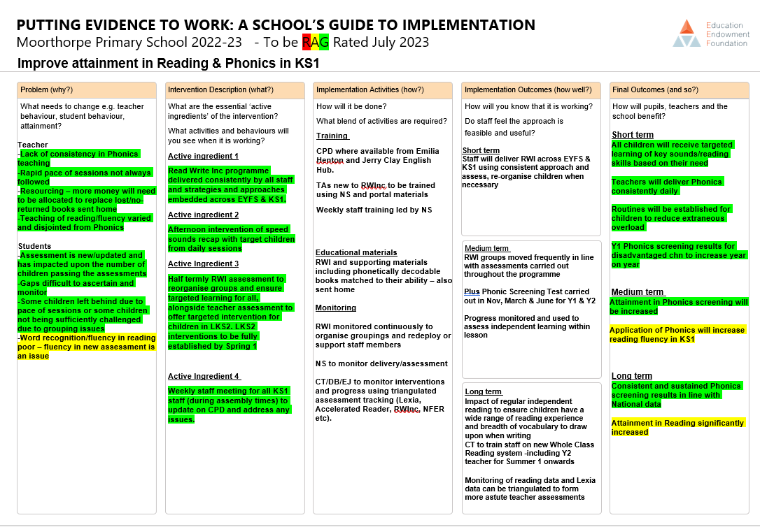

Actions and evaluations:
- RWInc Comprehension to be purchased and CPD for staff to support the teaching of comprehension and to build fluency.
- CT has created a WCR format for Summer term for Y2 which is specifically focussed on building fluency
- Talk through stories

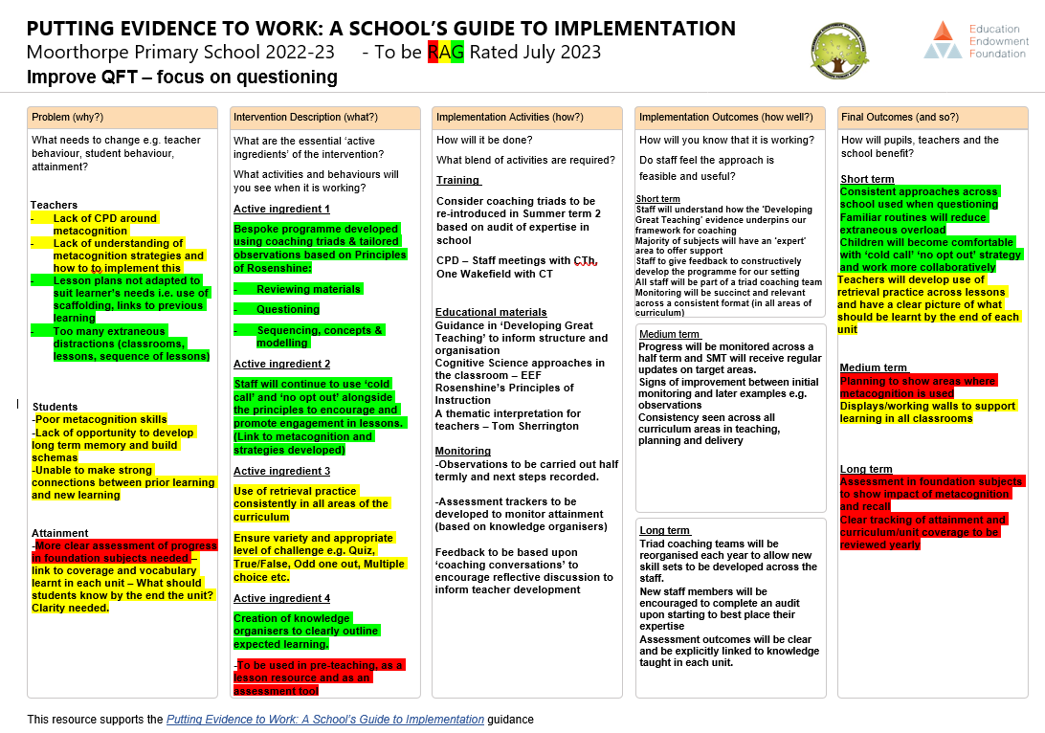

Actions and evaluations:
- Metacognition
- revisit theory briefly but then provide strategies and examples for staff. HD to deliver on INSET day
- CPD and further review of theory of metacognition staff meeting – Spring 2? (Staff to bring an example series of lessons/unit of slides where retrieval/metacognition sessions have worked well)
- Assessment in the foundation subjects – subject leaders to create the knowledge organisers then pass to staff in advance. CTh to address assessment strategies with subject leaders Sept+
- Knowledge organisers (once given in advance) can be used as a ‘pre-teaching tool’
- Checking for understanding / retrieval strategies to be used more effectively in class, e.g. at the start of a new lesson. Provide examples.

